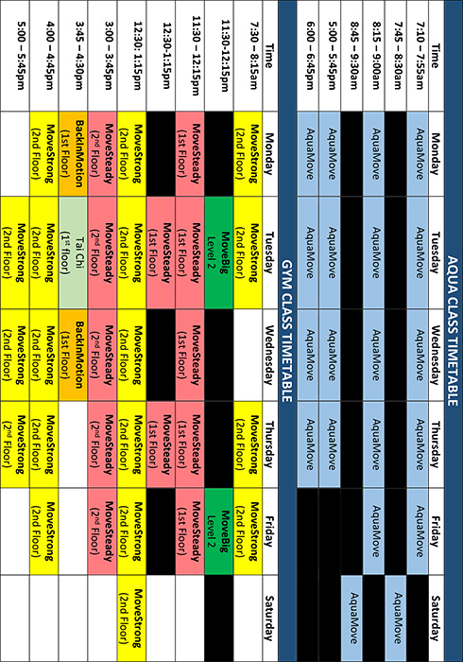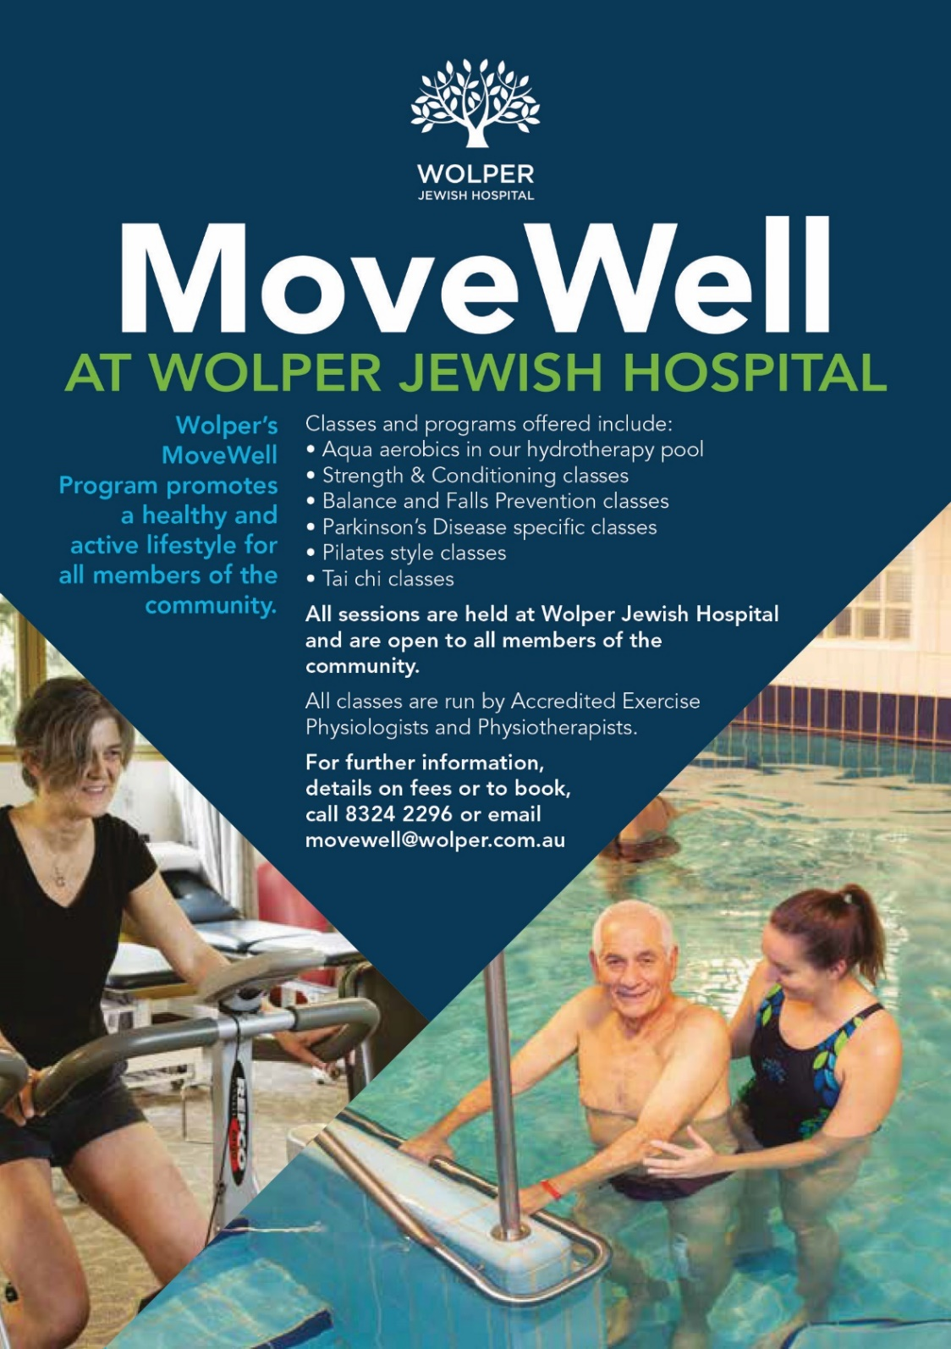
MOVEWELL GYM & AQUA CLASSES

MoveStrong – Strengthening and Conditioning
Suitable for participants that are independent and looking to improve strength, flexibility and fitness. Class is conducted in a circuit format using exercise machines and free weights to strengthen the whole body and improve fitness.
MoveSteady – Falls and Balance Class
Class is suitable for participants who are independent or using a walking stick or frame. Exercises focus on balance, leg strength and posture to reduce the use of aid and prevent falls.

Tai Chi – Shebashi
Tai Chi is a gentle form of exercise focusing on slow, controlled movements. Benefits include improvements in strength, posture, balance, mental relaxation and breath control. It is a low impact form of exercise, suitable for those with arthritis and osteoporosis, reduced balance, heart conditions and back pain.

MoveBig – For people diagnosed with Parkinson’s disease
This class includes aerobic exercises and exercises that focus on high amplitude and big movements in order to improve strength, balance and confidence.

BackInMotion – Core stability and spinal health class
Pilates inspired class designed to improve core strength, functional movement and flexibility and increase overall body awareness. Our BackInMotion class caters for people with lower back pain or spinal concerns.
AquaMove – Aqua-Aerobics
Classes focus on improving conditioning, strength and flexibility via water-based exercise in our hydrotherapy pool which supports the body and reduces impact on joints. Classes are suitable for individuals with pelvic floor weakness, pre/post-natal and spinal injuries/conditions.

Please note that all exercise classes are 45 minutes in duration. All Aqua classes are conducted in our chlorine-free heated pool. All participants must be continent and safe in the water to attend. Please discuss any suitability concerns with your GP or staff prior to commencing exercise.

BOOKING INFORMATION

2020 Gym & Aqua Term Dates
Term | Dates
Term 3 | Mon 6 July – Sun 27 September (12 weeks)
Term 4 | Mon 28 September – Sun 20 December (12 weeks)

Please note that there is no break between terms.
Mid-term enrolments are accepted.

2020 Fees
Class | Full Rate | Concession Rate
Gym & Aqua Classes | $28/class | $24/class

Please note that fees are paid in advance before the commencement of term.

Bookings
Please note that all participants are required to complete a medical clearance form prior to commencing
At the time of booking a copy of the terms and conditions will be provided
Forms can be found online at www.wolper.com.au or by contacting the MoveWell Team.
For more information or to make a booking please contact the MoveWell Team via email movewell@wolper.com.au or phone 8324 2296

